

Tangram

Game

A Unity Android Game

You can set the APK and start the fun journey

**Tangram Game**

User Manual / Contents

**Getting Started**

Overview **3**

Legend of Tangram **4****-5**

Includes **6**

How to Play **7**

Build Process

Using Unity **8**

The Easy Levels **9**

The Medium Levels **10**

The Hard Levels **11**

Extra Scenes **12**

Uninstalling

Uninstalling the Game **13**

Contact Us

Thank You for Playing Tangram Game **14**

# Overview

Welcome to Tangram game! This manual will help you find your way around the excellent mobile game offered by Fatih Buğur and M.Berkay Kaya. Whether you have just downloaded APK for the first time and are looking for a way to get started, or you have been playing our game for several days but still need some tips, this guide will help you to play easily . First, let’s begin with a few notes on how to play the Tangram Game User Manual.

* The Tangram Game contains colourful and different shapes for the patterns to fill, allowing you to rotate and drag through the pattern and drop shapes in the pattern.
* Touch the screen with one finger to drag shape and use two fingers to rotate shapes.
* If you don’t think shape is in the correct pattern, feel free to try again with other patterns

## Minimum System Requirements

* Android 4.0 or later
* 42 MB space on the phone memory

**Note:** You must reach developers to get an Apk and you can only play the game in Android phones.

# Legend of Tangram

The ancient Chinese story of the tangram is that a sage ,a wise old man was to take a precious sheet of the glass to the king who needed a window in his palace.The square piece of glass was wrapped in silk and canvas and carried in the sage’s backpack.The journey was long, the sage crossed a desert and rivers,he travelled through forests and fields. He arrived at a rugged mountain range and climbed to the summit of a high,rocky peak. At the top of the mountain he looked into the distance and glimpsed the palace he was travelling to. Pleased that he had almost arrived, he stumbled and tumbled down the side of the mountain, the glass was broken. When he met the king he told of his journey and admitted that the glass was broken. The square glass was unwrapped from its silk and canvas case and the sage was surprised to see that glass was not shattered but divided into seven geometric shapes.



The sage moved the shapes around and made images to describe his journey





He showed the king his home, a camel he had seen in the desert, monks he met on his way, a boat on the river he crossed and mountain range where he fell.The king enjoyed the geometric images and had the shapes recreated in wood…Tangram s were invented.

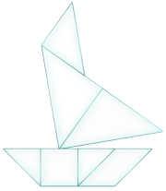



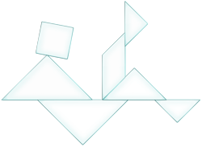

## The Game included shapes in the shapes folder:

* Large Triangle (2x)
* Parallelogram
* Medium Triangle
* Small Triangle (2x)
* Square

## 

## Scripts:

* GridManager
* LoadGame
* Validate
* Utils
* AppConstant
* DetectTouchMovement
* GridManager
* StartScene

# How to Play

There are 9 levels (Divided 3 modes) to play. Tap the button which the level you want to start. When the level starts, you should try to fill the pattern with the shapes below. Use 1 finger to drag and 2 fingers to rotate. Remember you can only use 1 shape for 1 pattern. After you fill the patterns correctly (filled and no shapes left behind) you will pass to the higher level. After first 3 levels you will be back to homepage. You can pass to the hard levels or stay in line and head to medium levels. Have fun!

## Game Scenes:

* + 3 level of easy mode
  + 3 level of medium mode
  + 3 level of hard mode
  + Homepage
  + Help
  + Developers

# Using Unity

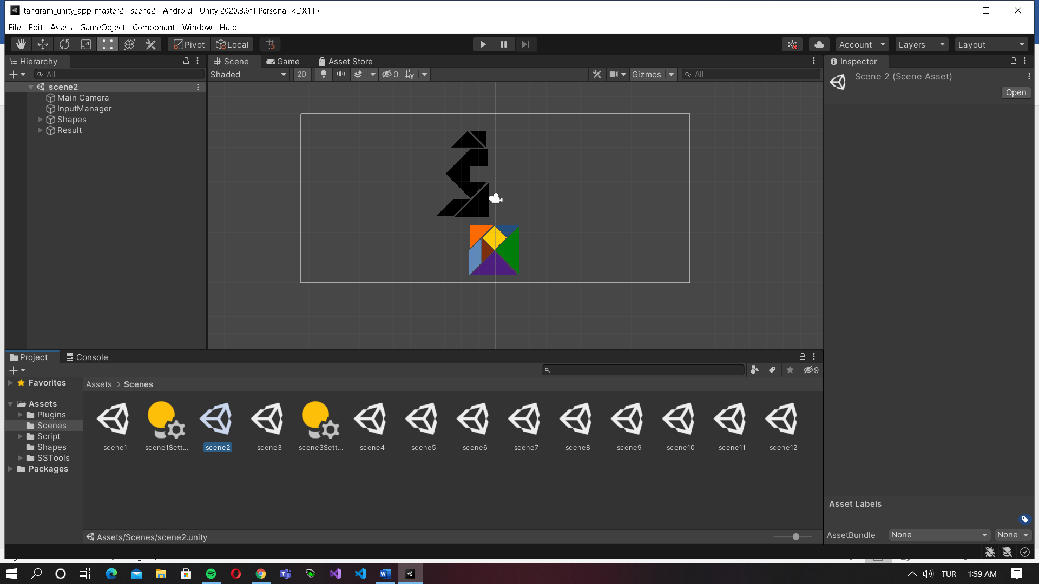

To able to build this game, we upload the shapes,background to unity files then created scenes. To work and load a scene, you need scripts which means coding. After we code where to summon shapes and locate the patterns we bind scripts with game objects.

We designed all levels according to the sheet came from customer requirements. We coded algorithms in C# to be able to drag, rotate and autofixed drop shaped to the patterns. After testing everything we build the APK and uploaded to an android phone to run customer tests. When the tests are passed we release an APK to the gamers.

# The Easy Levels

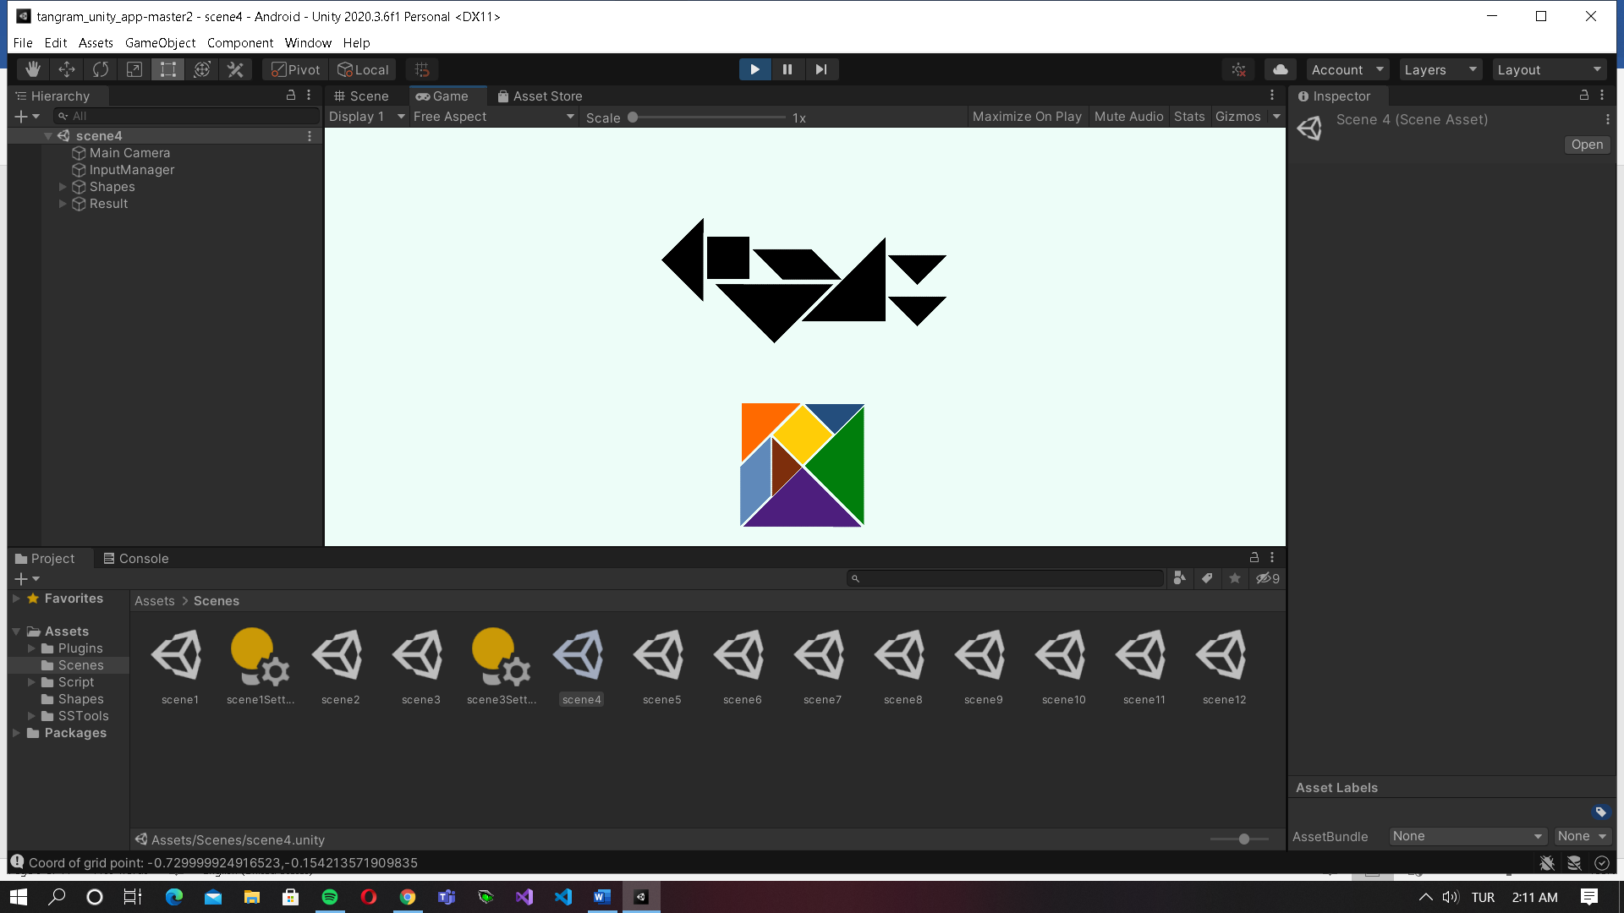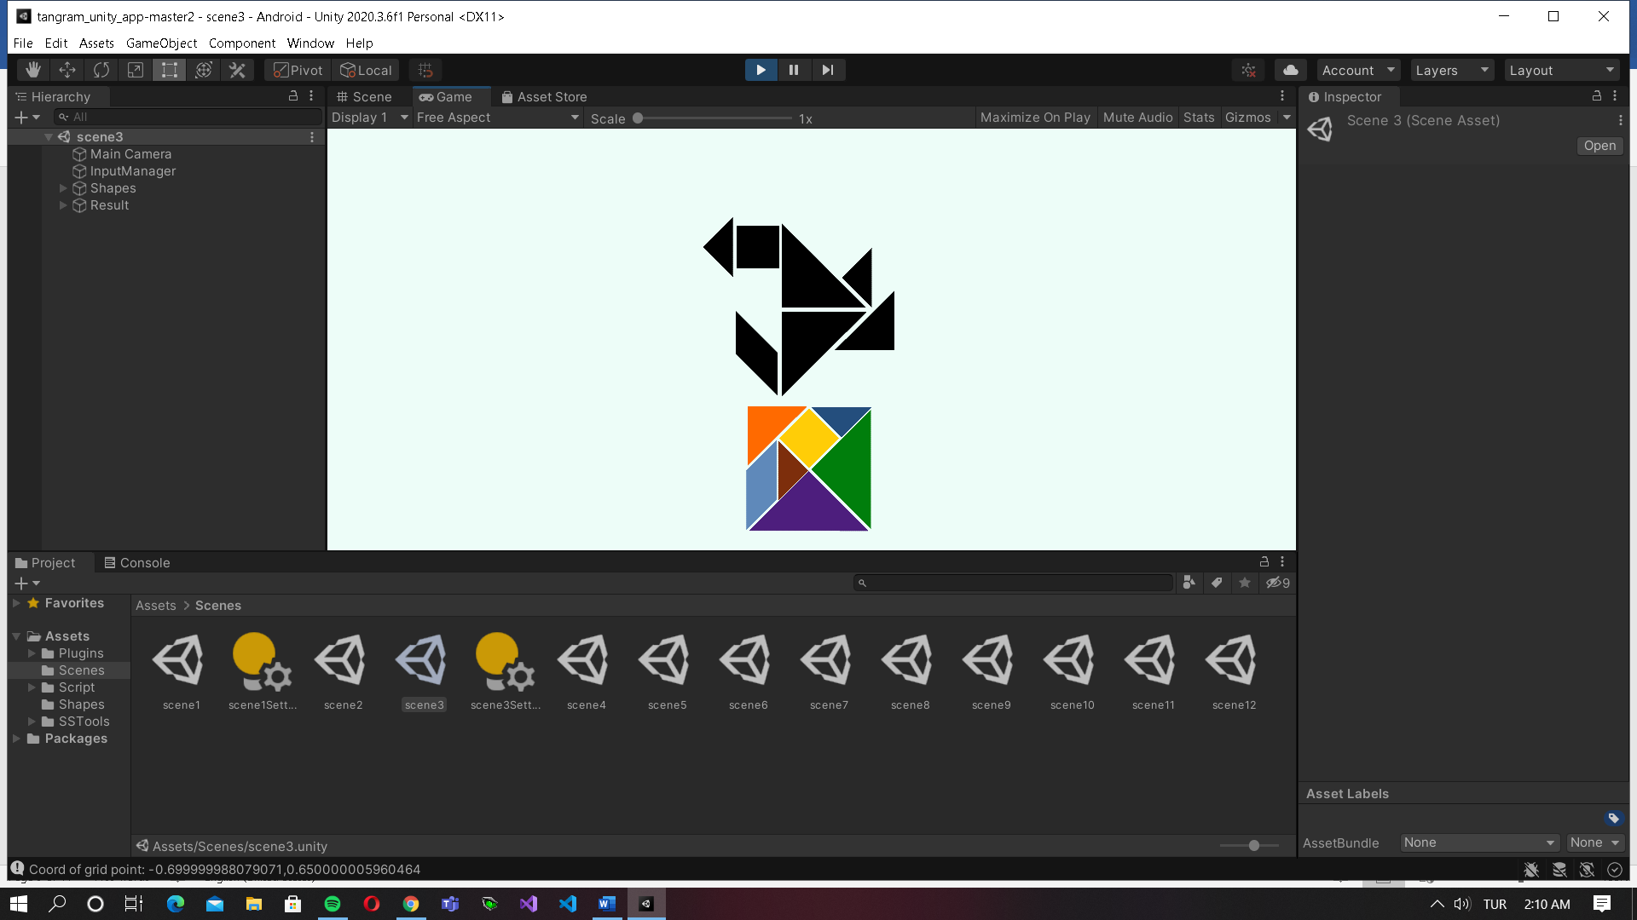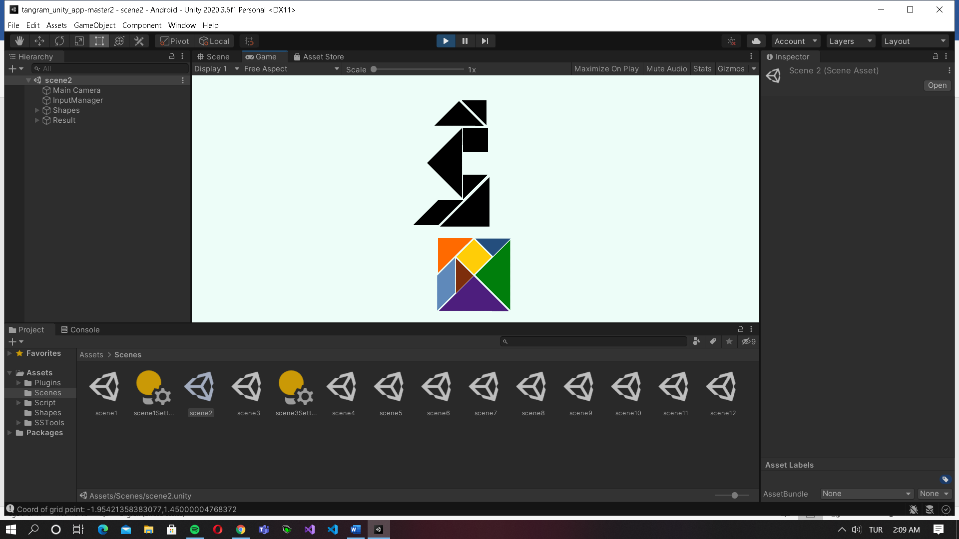

The easy levels created for practicing the game for the first time. Imagine the patterns come to life with the shapes you will fill. The rest will come to your mind.

## Tips for easy levels:

1. Just enjoy the game and don’t rush, it is your first experience.
2. Try to rotate shapes slowly and let the autofix fill the shape exactly to the pattern.
3. There are aren’t any shapes that you don’t see. Remember this is a huge tip.

# The Medium Levels

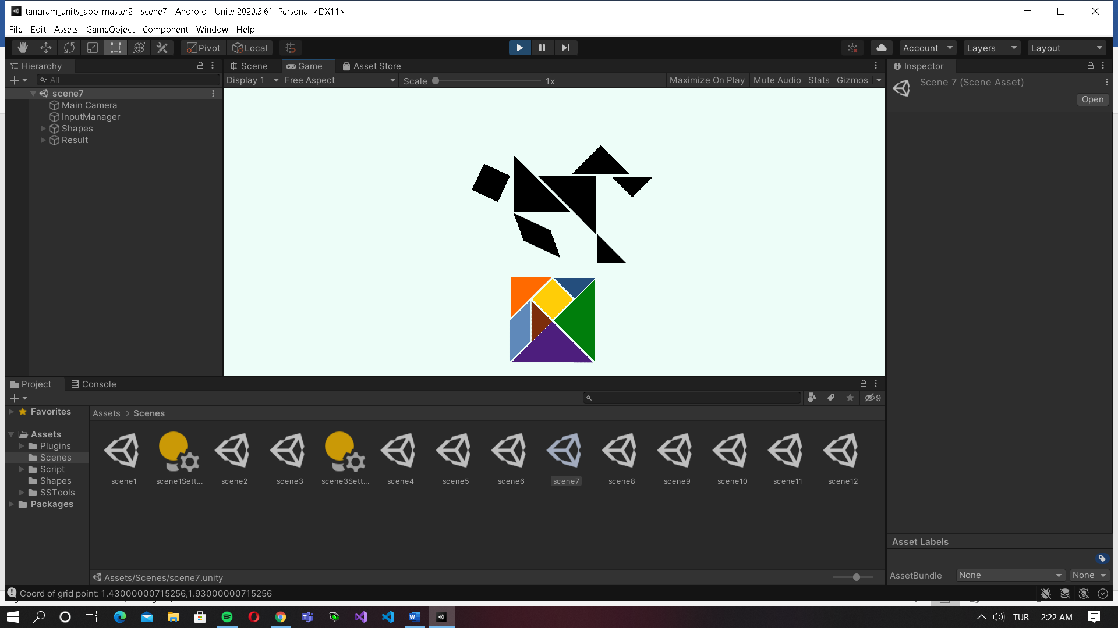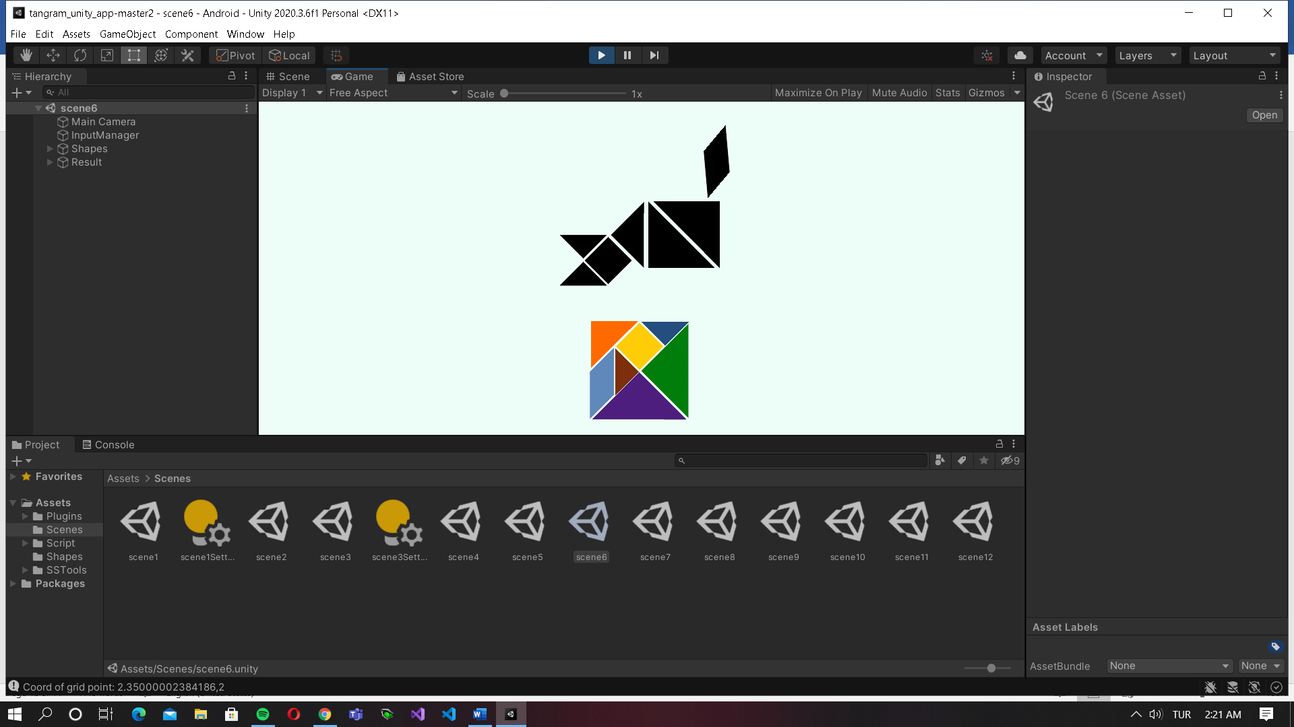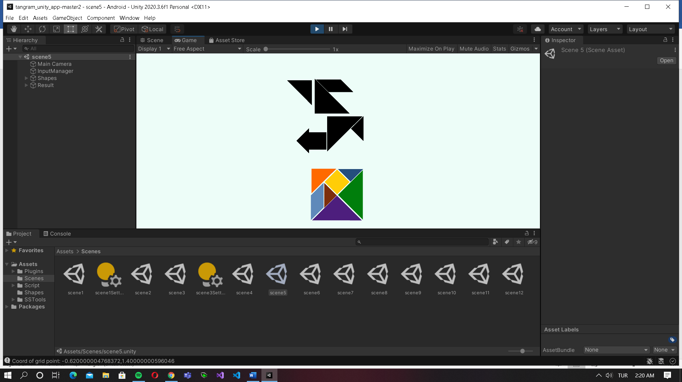

The medium levels created for getting use to the Tangram game and learning the logic. Just try little bit harder but don’t worry it is not that hard.

## Tips for medium levels:

1. Start with the big pieces. It will allow you to see and guess the pattern more easily.
2. Try to rotate shapes more than previous levels and check if it fits.
3. Rotate your phone to see patterns from larger angle.

# The Hard Levels

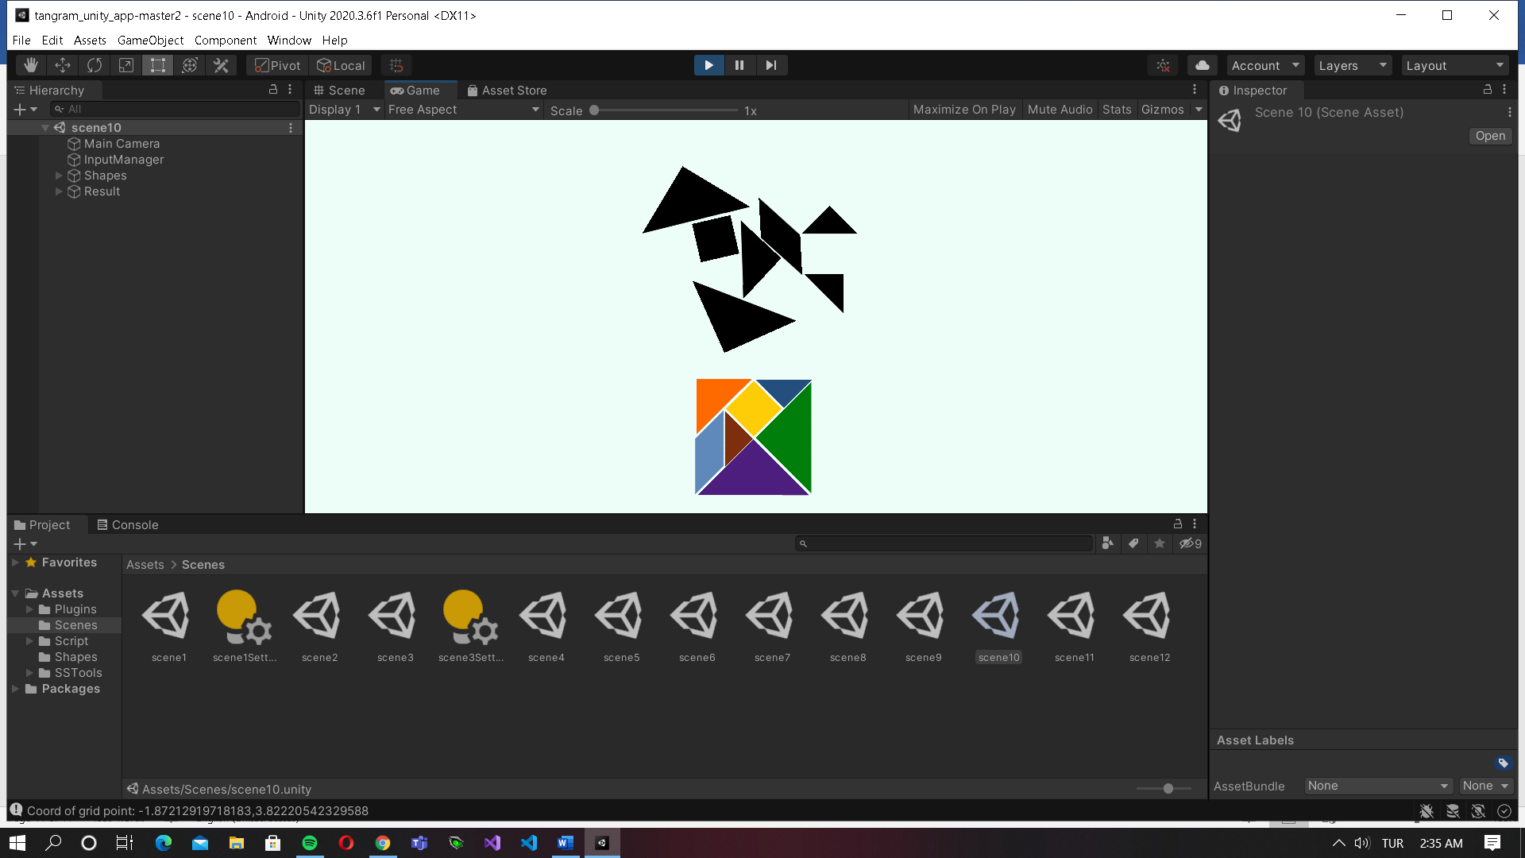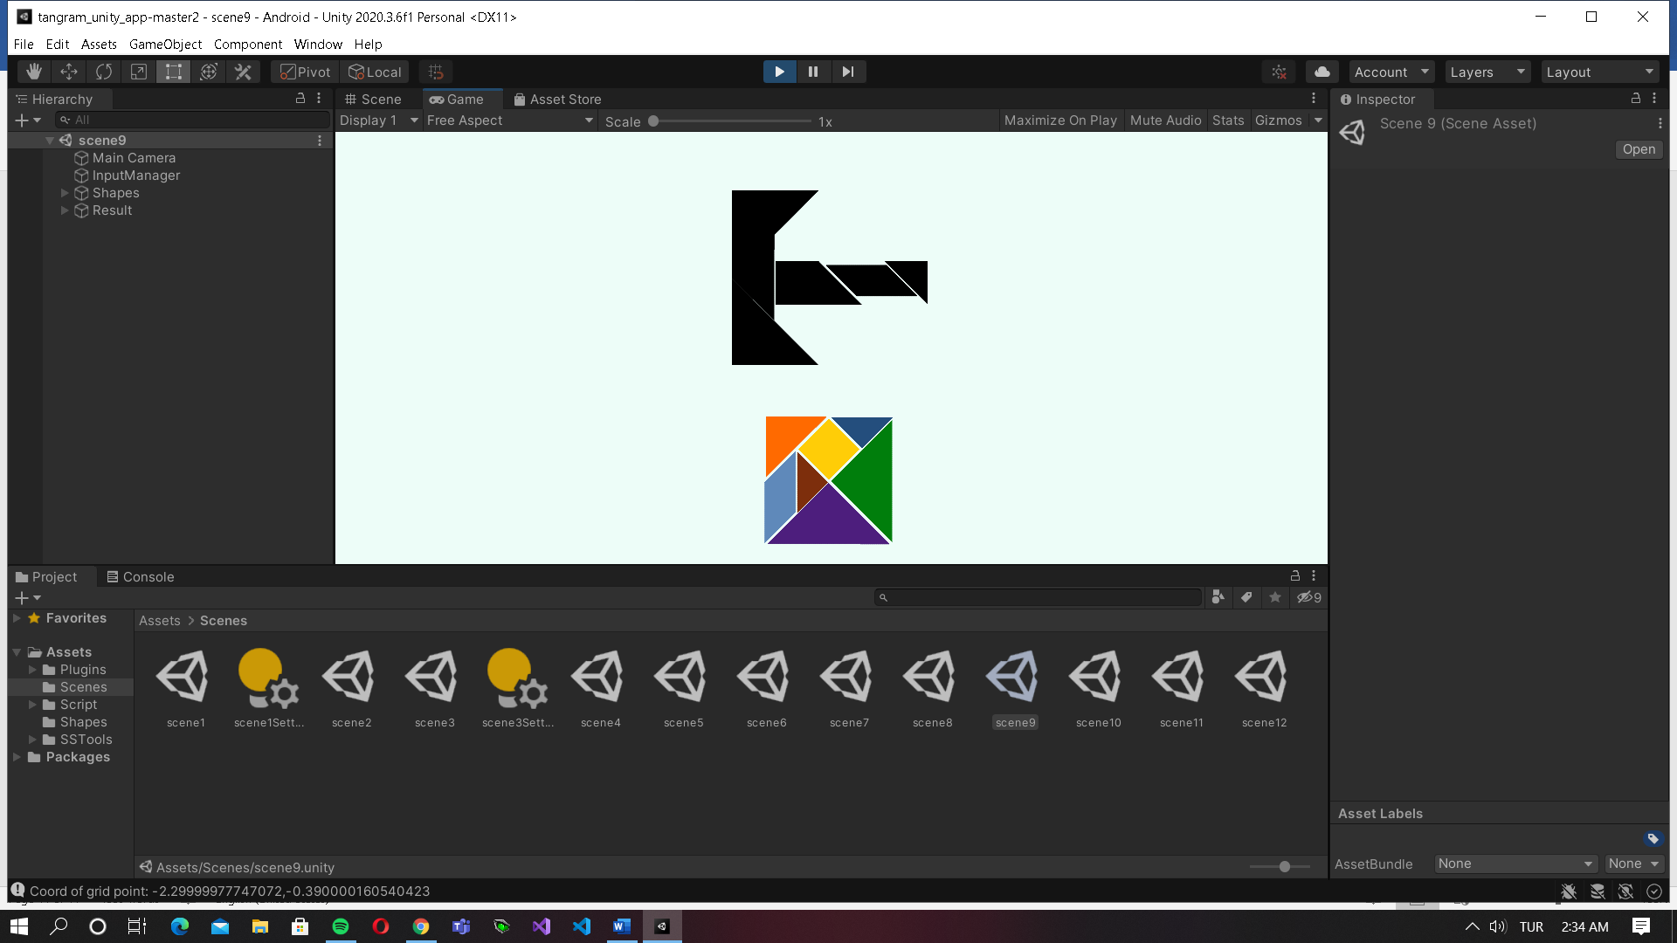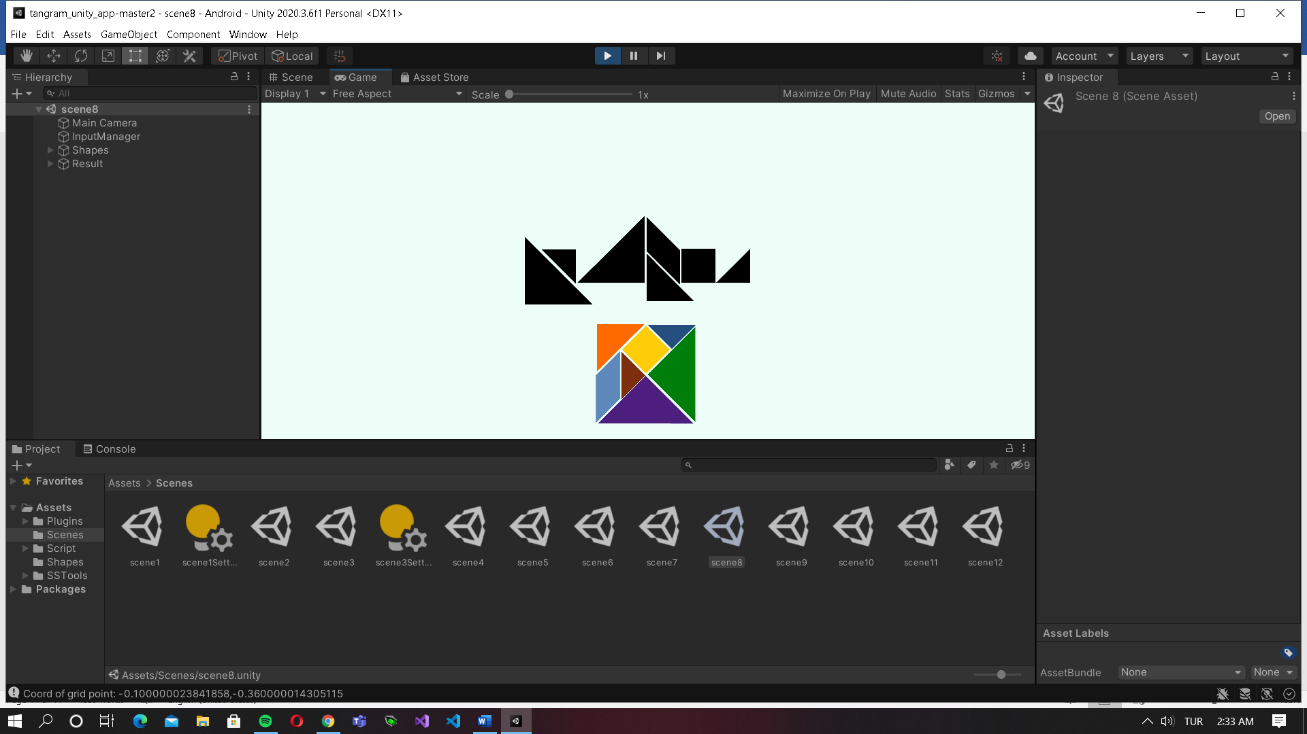

The hard levels created for challenge you and giving you a real brain exercise. Real Tangram fans will enjoy those levels and compete with their friends.

## Tips for hard levels:

1. Take your time and don’t give up. You can always have a break.
2. In those levels always use the larger angle it will ease things.
3. Use the shape for filling the patterns one bye one. Eventually one of them will fit in with Autofix.

# Extra Scenes

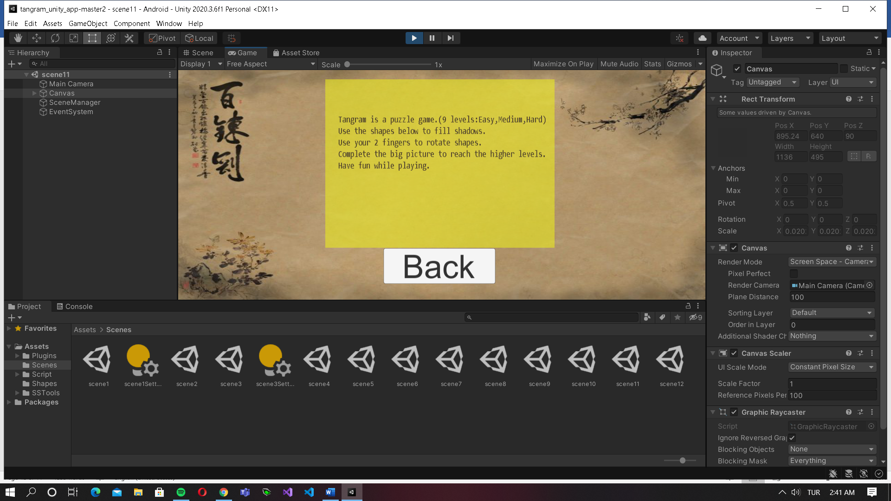

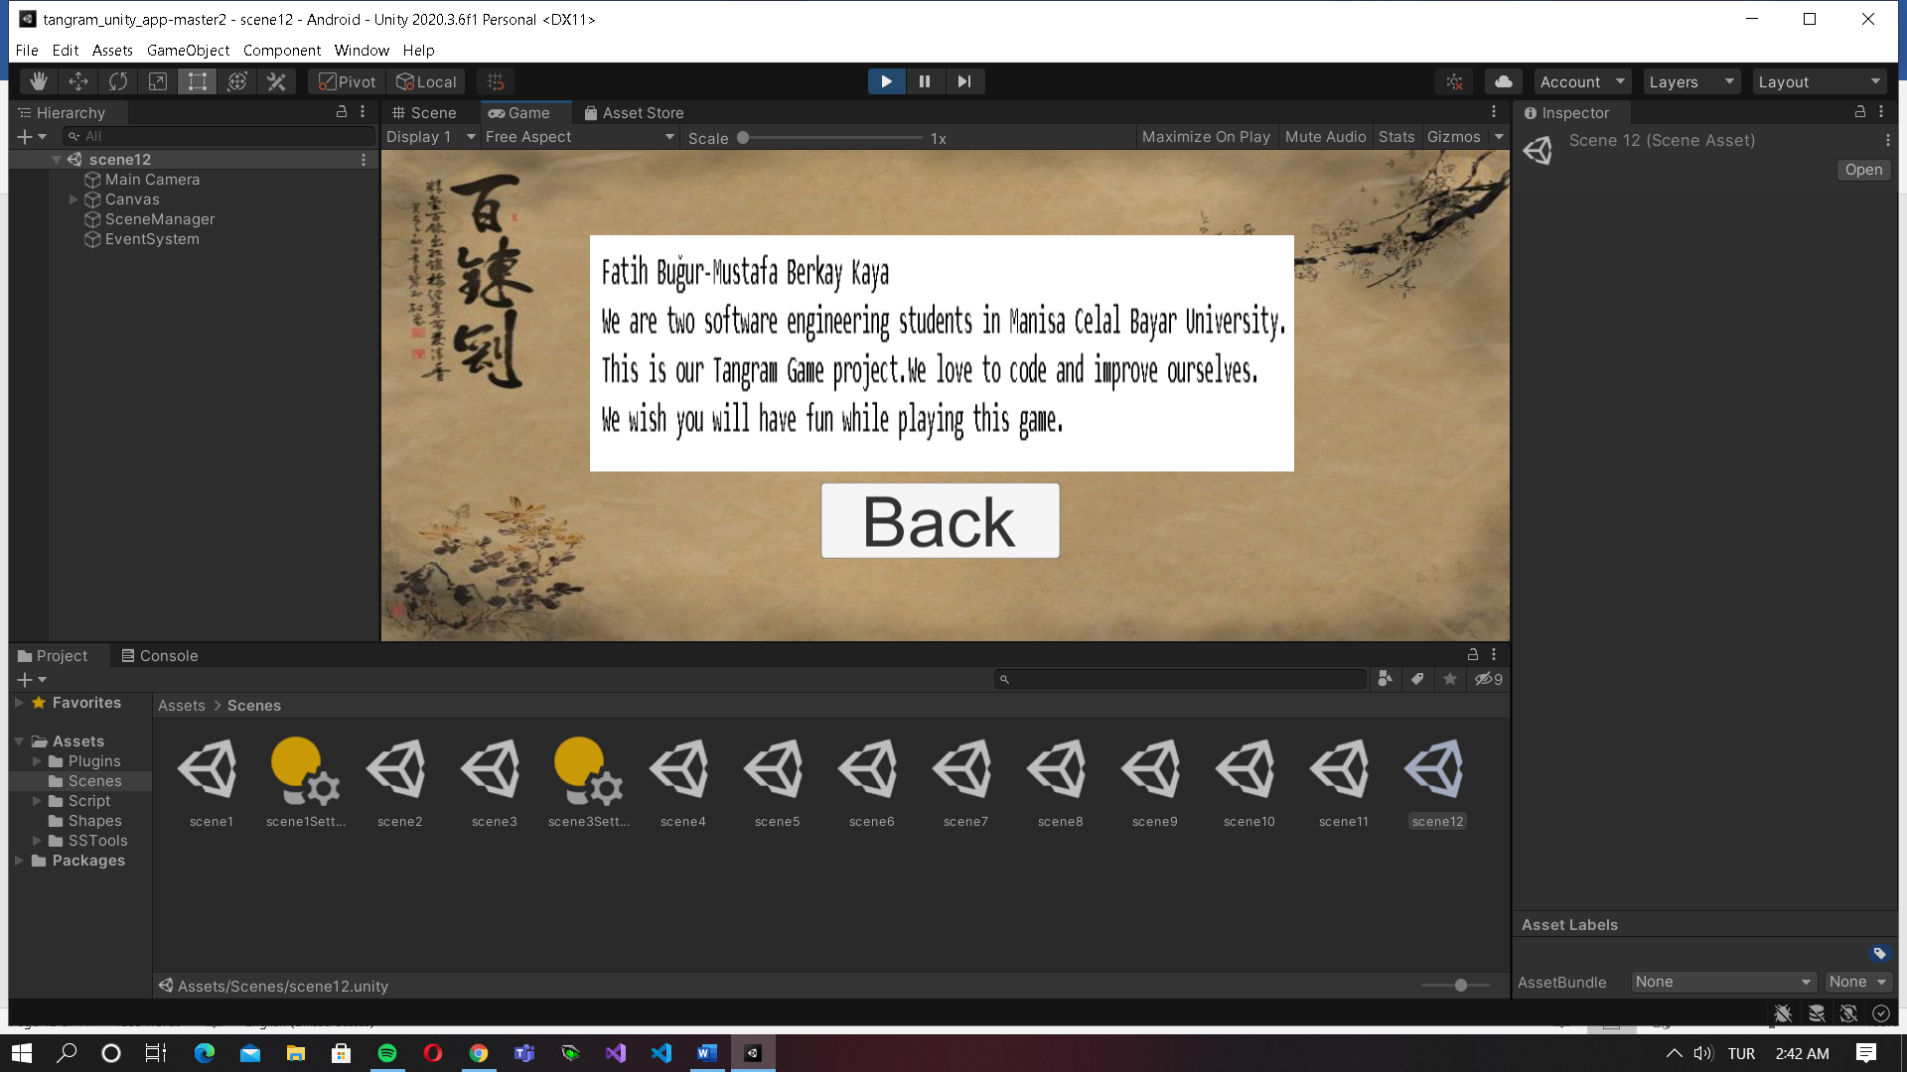

Help scene created for the ones who are very unfamiliar with Tangram. It teaches how to play and what are levels in different modes.

Developer scene created for the ones who want to know about developers.

You can check the User Manuel file also.

Tangram Game

User Manual / Uninstalling

# Uninstalling the Game

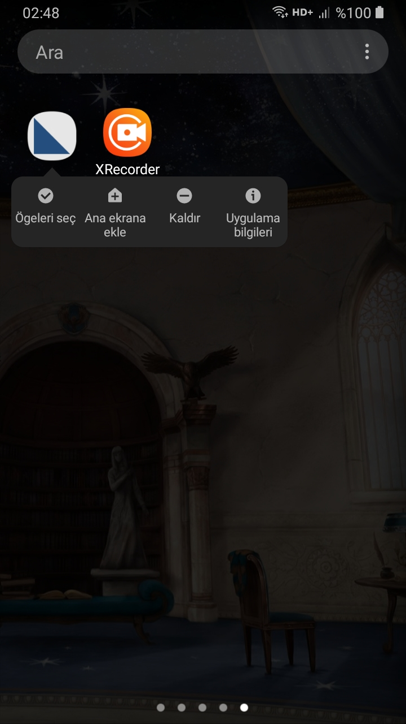

1. Go to App Menu .
2. Hold on the game icon.
3. Choose “Kaldır”(Turkish).
4. Tap “yes”.
5. It is removed.

Tangram Game

User Manual / Contact Us

**Thank you for playing Tangram Game!**

If you have any problems with the game, please reach us from our e-mail adresses

[*fatih.bgrbgr@gmail.com*](mailto:fatih.bgrbgr@gmail.com%20)

For more information about the game, see the help scene at Tangram Game

For more information about us and services we can provide, visit us at Manisa Celal Bayar University-Hasan Ferdi Turgutlu Technology Faculty. Turgutlu/Manisa

The Develop Team;

**Fatih BUĞUR**